**SMS Testing**

Once the application is up and running, there are few assumptions that we made as part of our application. They have been mentioned in our design document as well.

1. Admin account doesn’t have a sign-up page. We need to insert a Admin record manually. Use the below query:

INSERT INTO user_login (email, first_name, last_name, password, phone_no, role, username)

VALUES ('admin@gmail.com', 'admin', 'root', '123', '2332312', 'admin', 'admin');

1. Once a teacher sign-up with a new account, they cannot directly login.

Admin needs to map the teacher with a course.

1. One teacher can be mapped to only Course.

Now, once the admin record has been added. We are good to go with the application.

Login screen: <http://localhost:5500/homelogin.html>



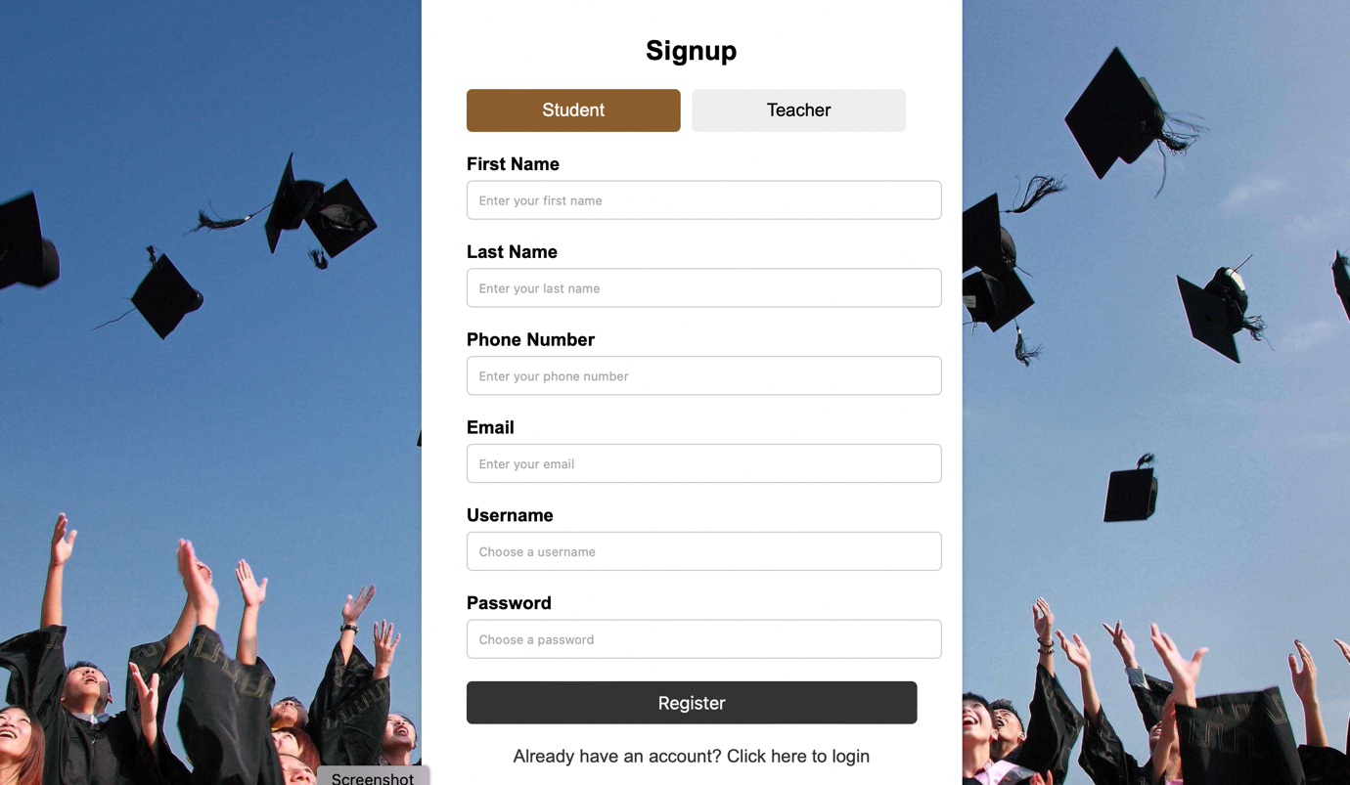

Now let me sign up 3 teachers.

John, Sebastian, Mike – 3 teachers has been signed up newly.

But they won’t be able to login until admin maps them.

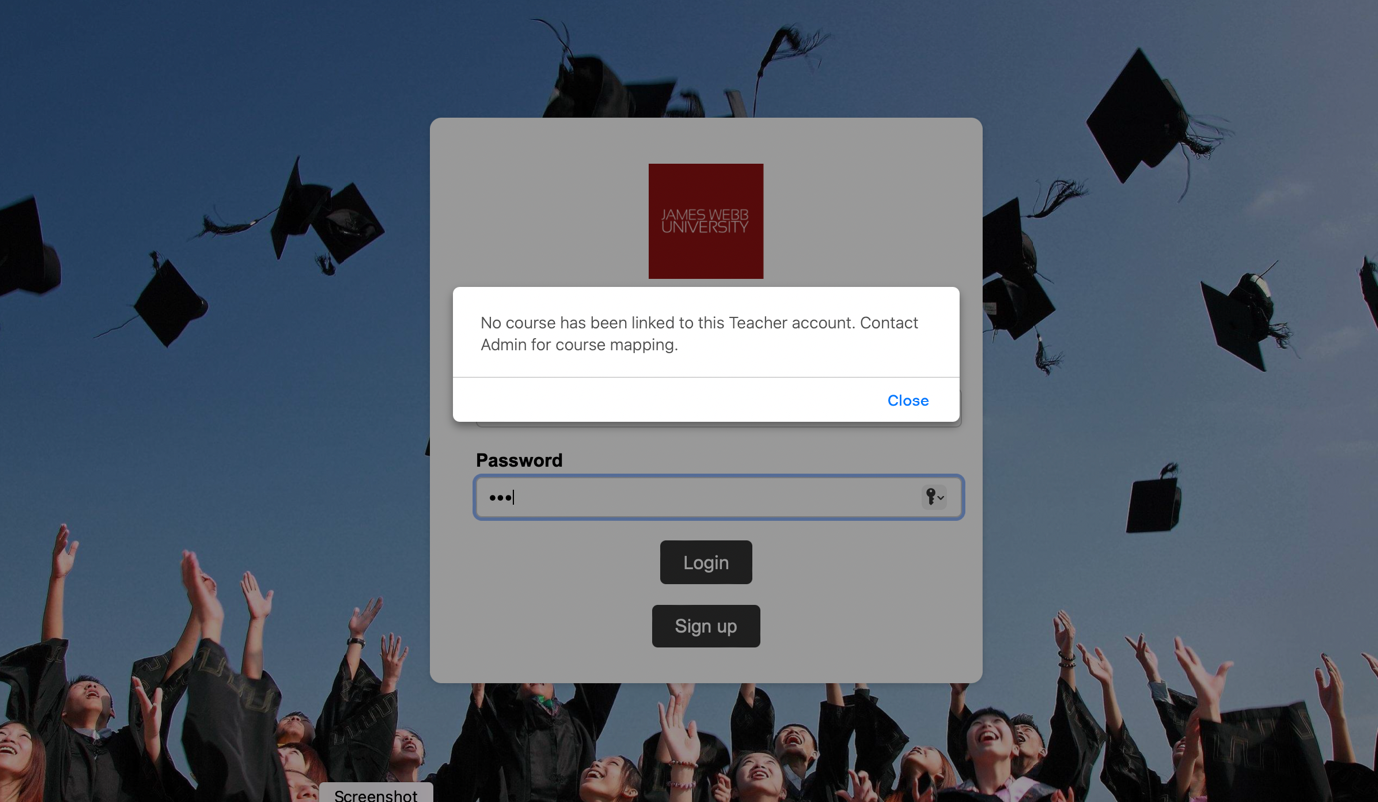

Now, let admin login and map the courses for them.



Mapping courses to the teachers:

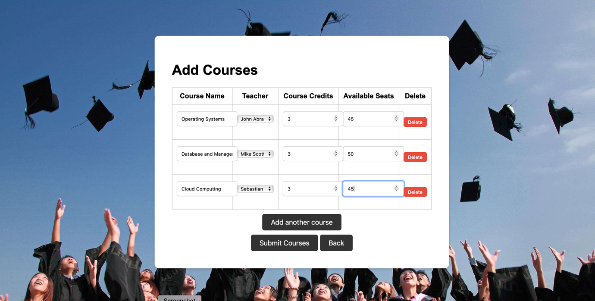

Now the teachers will be able to login.

Logged in to a teacher : John



A teacher will be able to do following things :

1. Update his profile
2. View total students enrolled in his course
3. Add content into his course
4. Add quizzes into his course
5. View any announcements posted by the admin

Similarly a new Student will be able to do the following things:



Student:

1. Updates his profile
2. Register for new classes
3. Browse the registered classes
4. View content/quizzes in the registered class
5. View announcements posted by admin

All the Rest APIs that are being called in the front-end are tested via Post man.

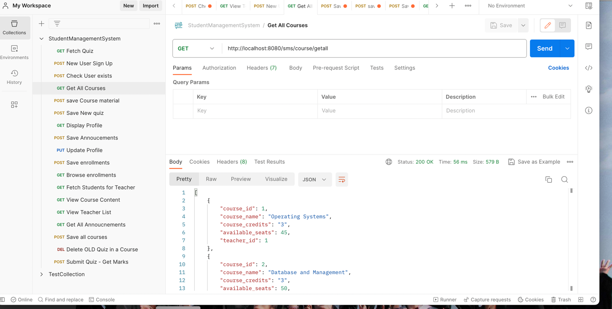

Postman collection will be attached in the git repo.